**First steps with Kinetis SDk**

This series of tutorial will help you get started with Kinetis SDk for the FRDM K64F board.

To start write code and use the kinetis SDk you need to download and install the Kinetis Design studio

<http://www.nxp.com/products/developer-resources/software-development-tools/kinetis-design-studio-integrated-development-environment-ide:KDS_IDE>



KDS ( Kinetis Design studio) is an integrated environment to write your code, open examples, compile and produce image for download to KDS.

To download the IDE you need to have an account at NXP, so just create one.

After you got into the download page, select the download according to your OS

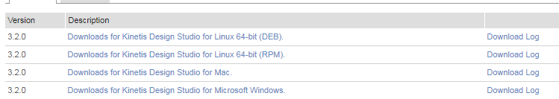

Once finished, you need to download the Kinetis SDK for K64

**Kinetis SDk**

Kinetis Sdk is now being download from this web page:

<https://mcuxpresso.nxp.com/en/welcome>

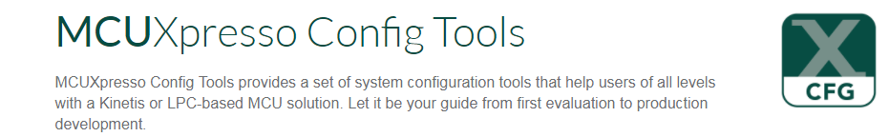

Press the Sdk builder

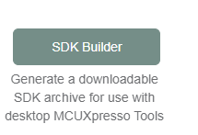

The builder can create an Sdk for you to download from many of the Nxp boards.

We need the FRDM K64f

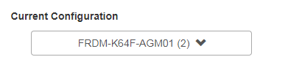

Once chosen , you are ready to download

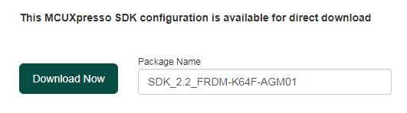

As we can see the current Sdk version is 2.2

Once you download, make sure you extract it in a known place to be able to open it from KDS.

**Working with Kinetis Studio IDE**

Kinetis Stduio is based on eclipse.

And in eclipse a project always start with a workspace.

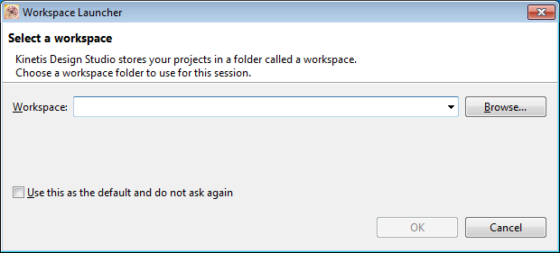

So in order to get started you need

1. Select a new working in case you are creating a new project.
2. If you already created a workspace, you can reopen it by selecting it again,

We will create a project for toogle GPIo , so lets create a working space called ToogleGpio

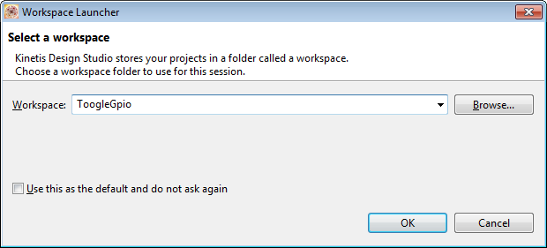

After the workspace selection , you will see this page

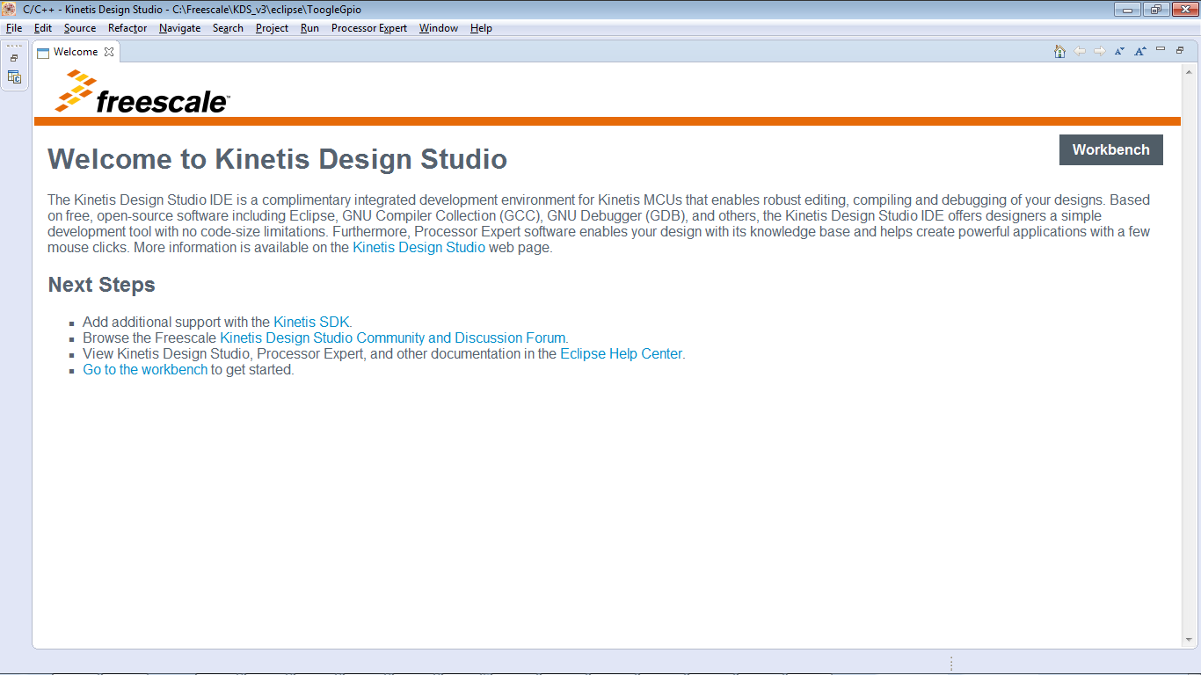

Close the welcome, and you will see that screen:

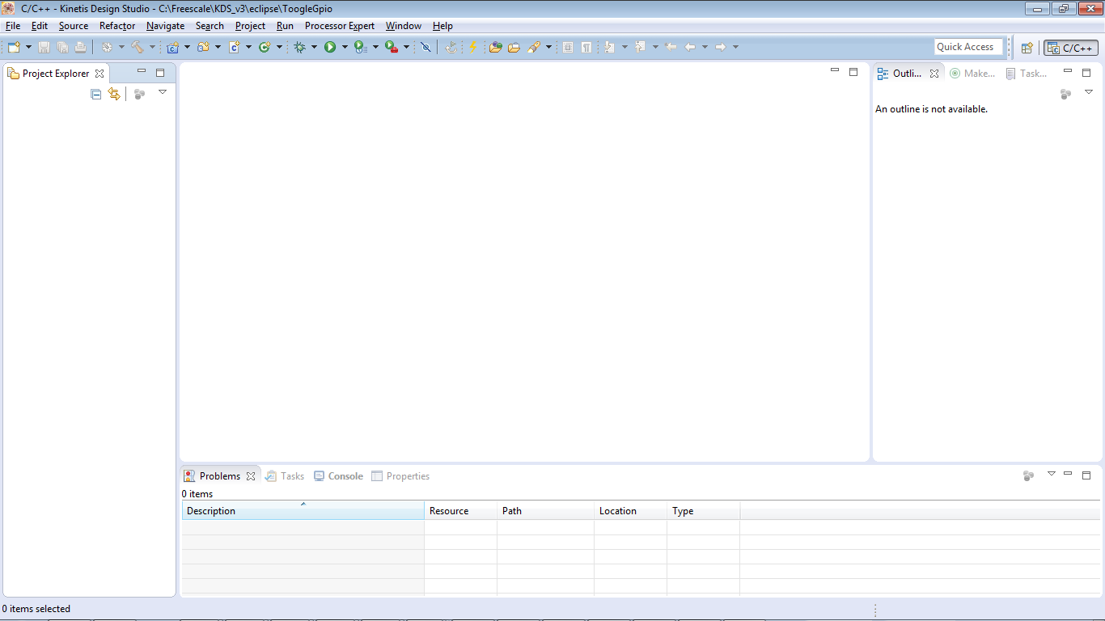

The kinetis Sdk folder layout is as following:

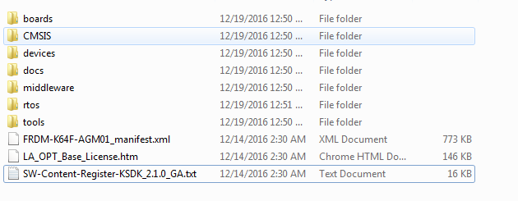

Kinetis Sdk has many examples , for many of its peripherals

You can see it in boards\frdmk64f\driver_examples

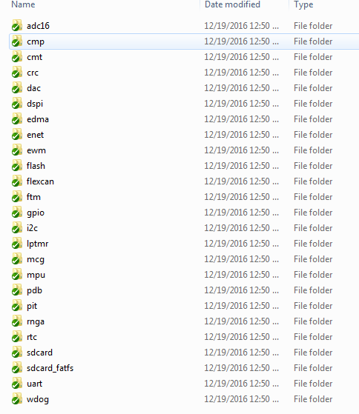

We want to open the led output example:

C:\Topaz\SDK_2.1_FRDM-K64F-AGM01\boards\frdmk64f\driver_examples\gpio\led_output

The project settings are always located in a folder call Kds

\kds

The full path for the led output example folder is:

boards\frdmk64f\driver_examples\gpio\led_output\kds

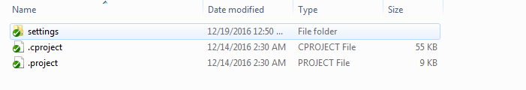

How to open that folder in Kinetis Design Studio:

Copy in to clipboard the full path:

This is in my computer, in your computer you probably place it somewhere else:

C:\SDK_2.1_FRDM-K64F-AGM01\boards\frdmk64f\driver_examples\gpio\led_output\kds

In KDS , right click in the project exploer and select import

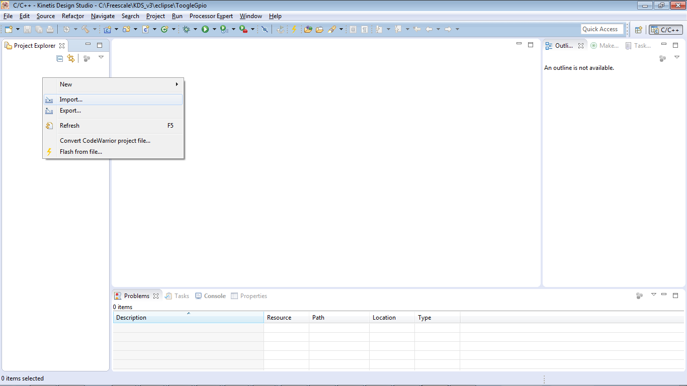

General->Existing project into workspace and press next

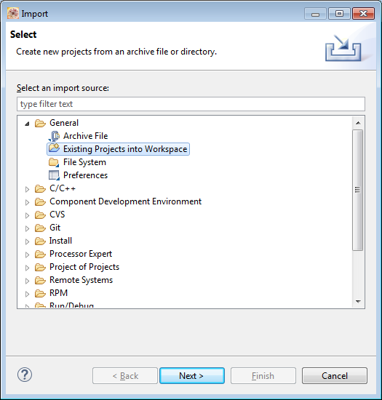

In the select root directory , enter the full path of the led output project and press enter

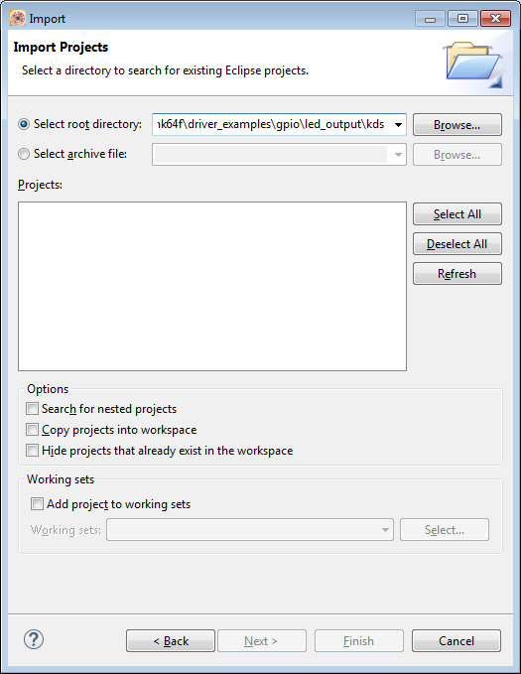

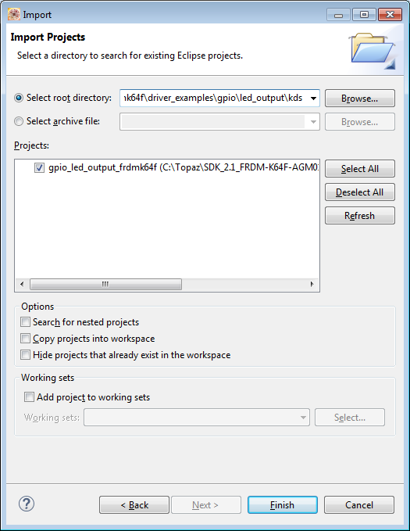

Click finished.

You should see the following screen:

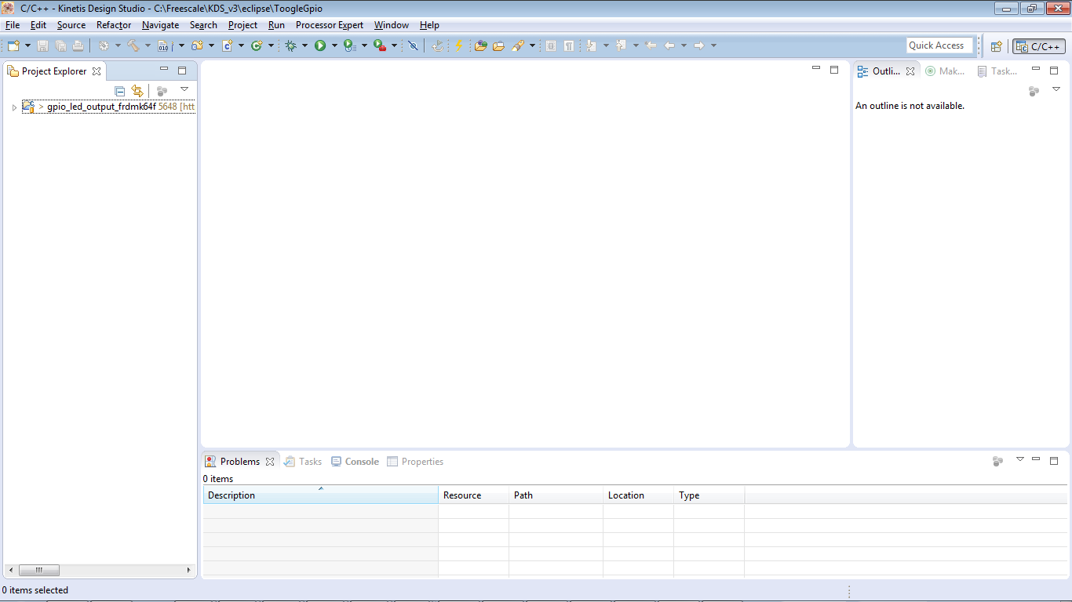

Expand the project view to:

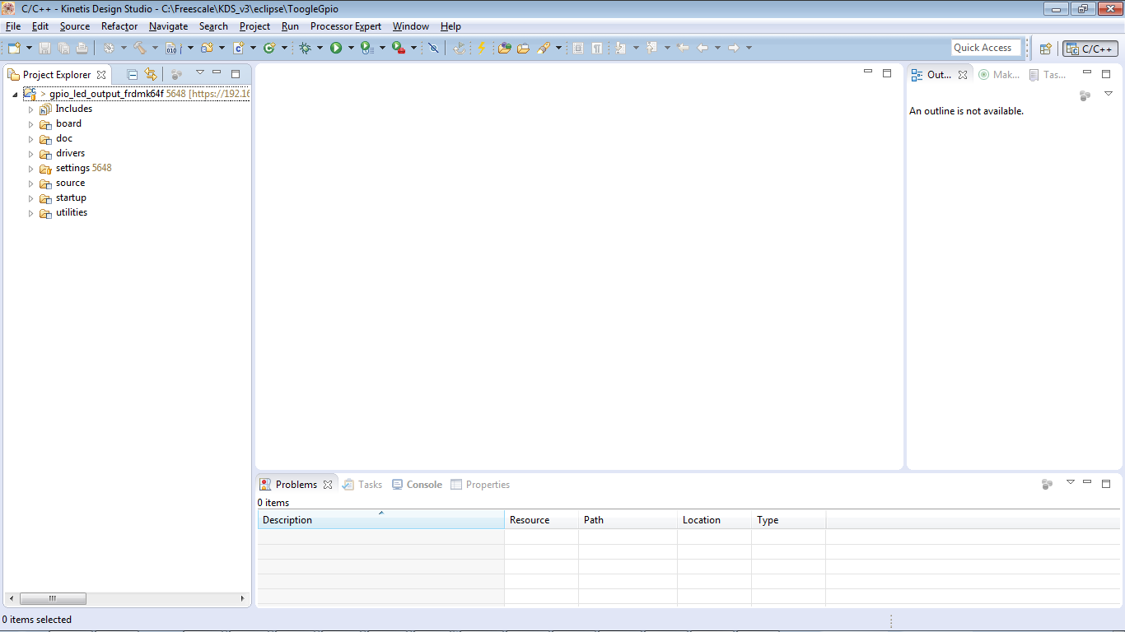

Next steps:

1. First compilation
2. Change target output file to binary
3. Exploring the code

Let build our project for the first time:

Select project->build All ( Ctrl + B)

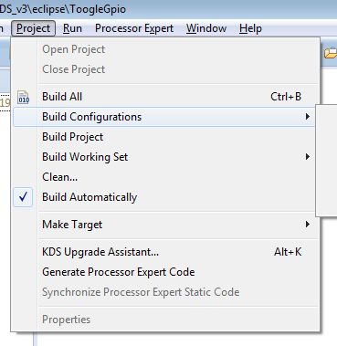

How to download the produce firmware into the K64F.

FRDM k64f is working with Mbed driver.

The MBED driver require a bin file.

Lets change the target output file to binary file.

Right click the gpio led project



And select properties

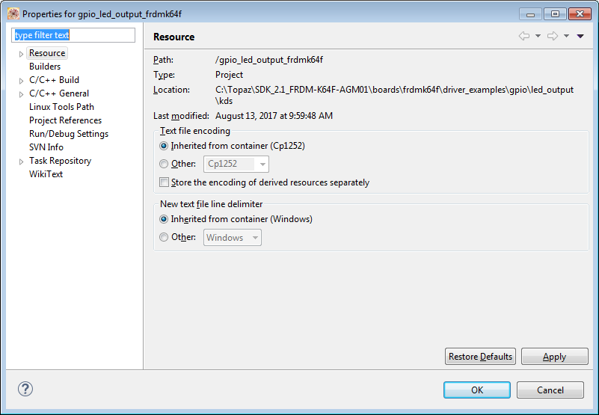

Expand the C++ build ->settings

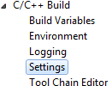

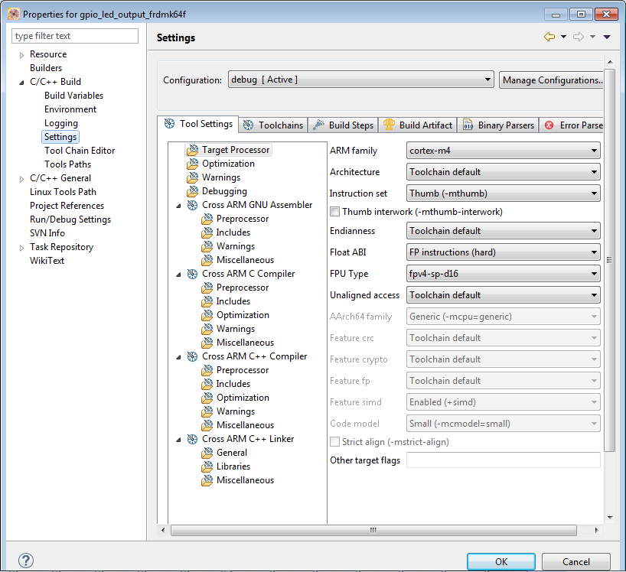

Select the toolchain tab

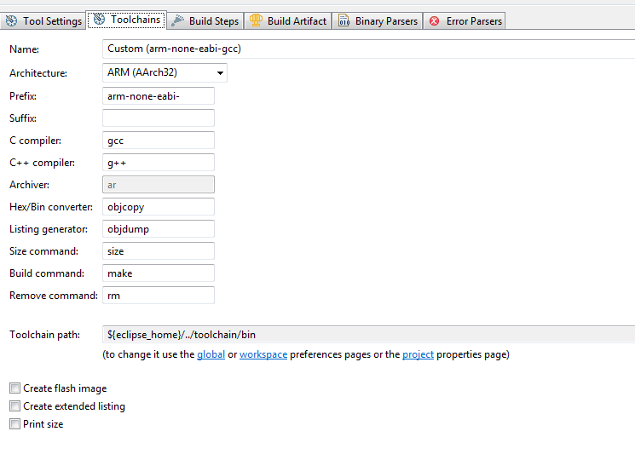

And check the Create flash Image

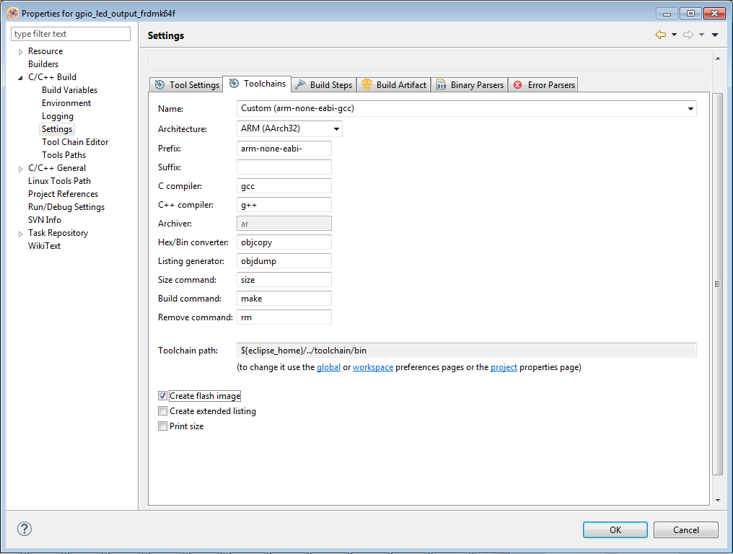

Press OK to save and close

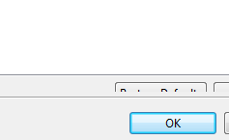

Go again to the properties by , right click on the project and select properties

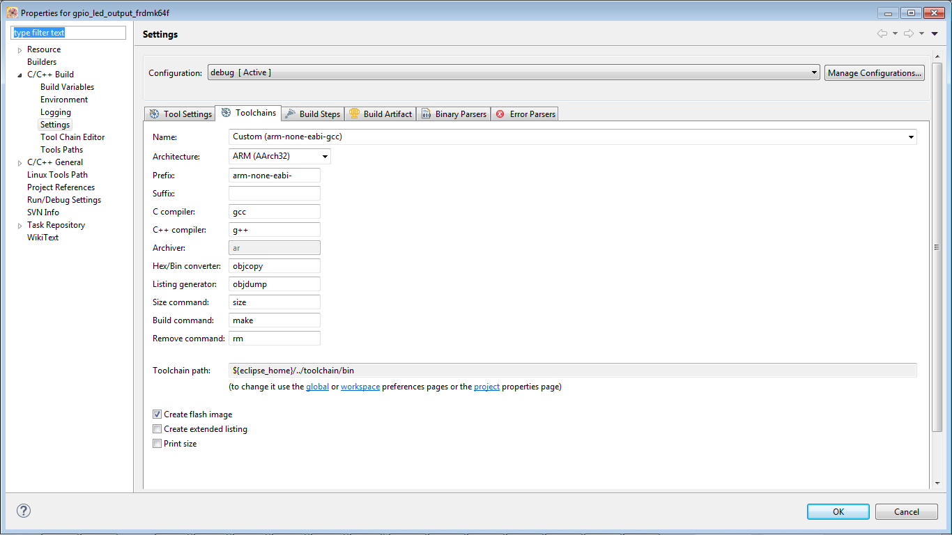

Now select tool settings tab

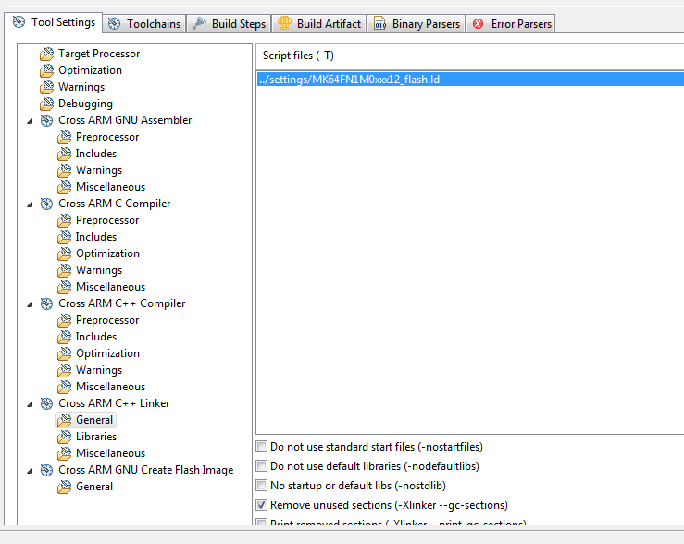

And click the general in Corss ARM GNU Create Flash image

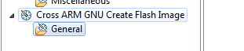

You should see:

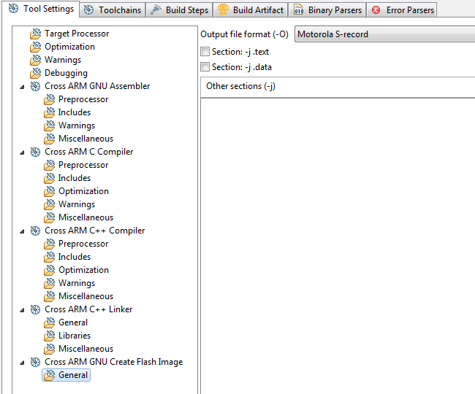

This will allow you to change **the output file format**

Change to raw binary:

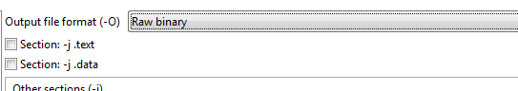

And click OK

Select Project ->build all to compile your project and to create the binary file

Where is the output file

Right click your project and now select resources

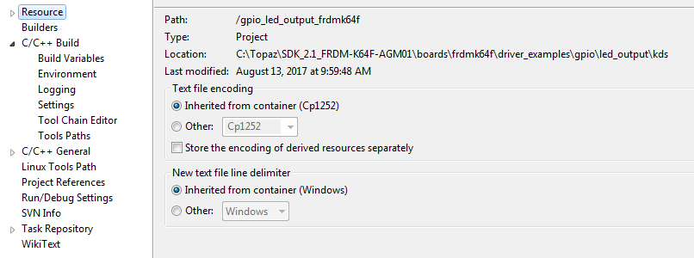

The location of the project is where the arrow indicates location

Open that folder in your explorer.

The binary will be in Debug directory:

C:\Topaz\SDK_2.1_FRDM-K64F-AGM01\boards\frdmk64f\driver_examples\gpio\led_output\kds\debug

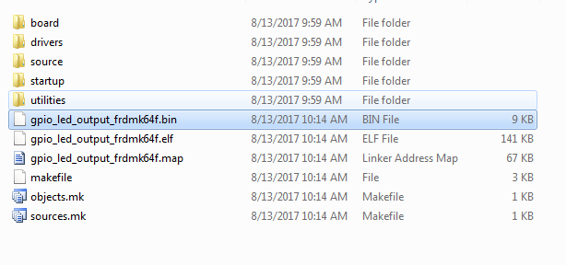

The gpio_led_output_frdmk64f.bin is the binary file that we want to transfer, burn , download or any other word you choose to the k64f board.

How do we do that you ask:

**Download binary firmware into K64**

The K64f let you download binary firmware to its internal flash memory by copy and paste or drag and drop the binary file, like are doing with any file in your OS.

But before we can start working with that option , we need to install a driver.

In windows:

Open

<https://developer.mbed.org/handbook/Windows-serial-configuration>

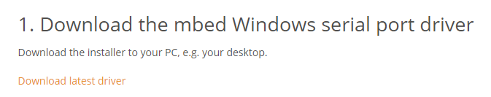



And install the mbedWinSerial16…exe

Once done, you can open your windows explore and see the MBED disk drive

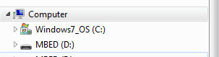

What left to do is to drag and drop the binary file into the MBED D drive

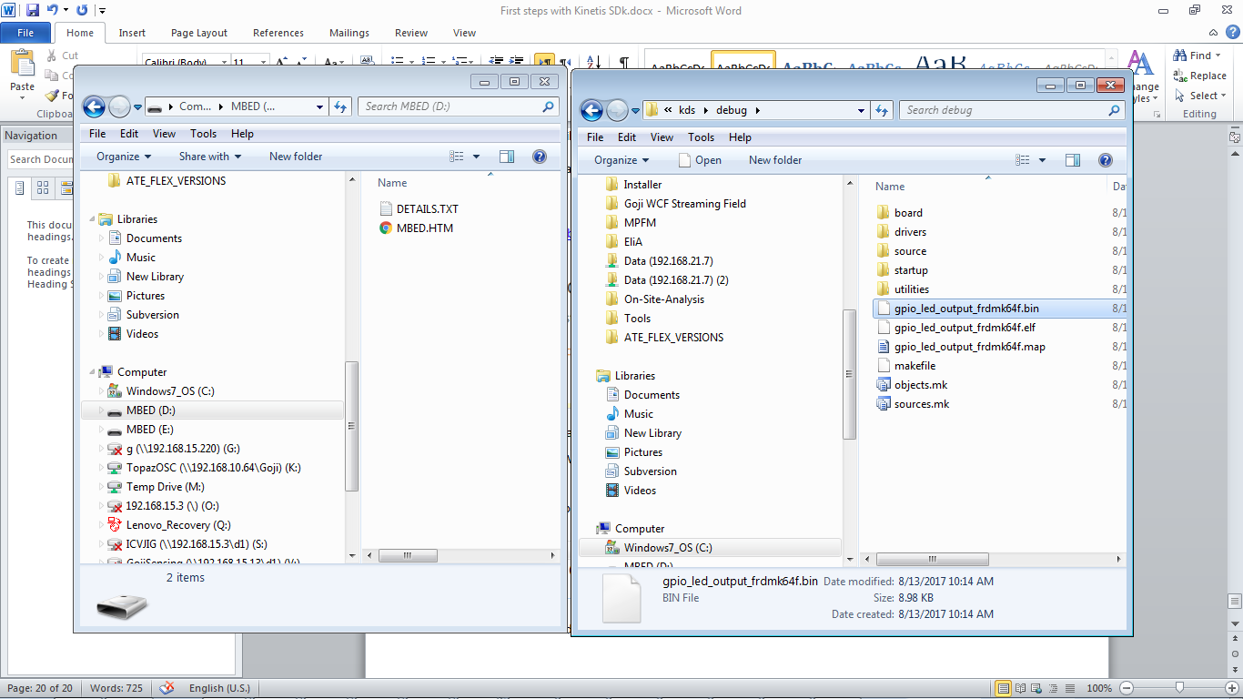

When the burning takes place, you will see a blinking led on the FRDM k64. Once it stopped blinking you the flashing completed.

**When the flashing completed you must reset the board to let the program start**

And you should see now the red led blinking.

Install Uart terminal and view printf on screen

The K64 has integrated UART in the USB already.

We don’t need to configure the uart , it is already configure for us in each example in the kinetis SDK.

You can use any terminal you like, but here are the steps to use putty.

Download putty for windows:

<http://www.putty.org/>

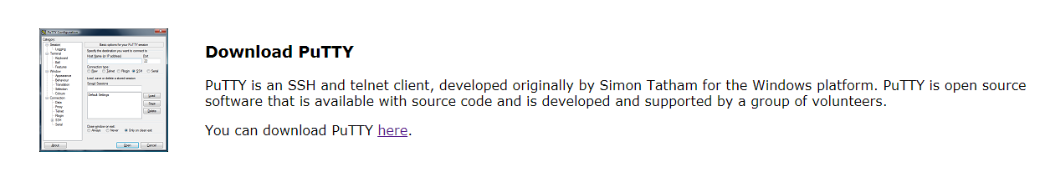

When you installed the mbed driver you should see that windows in system manager created a driver entry for you:

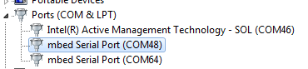

Here I have two k64 installed in my system,

Let’s open the COM64 , this is the one I download the firmware for it.

Configure putty to the following settings:

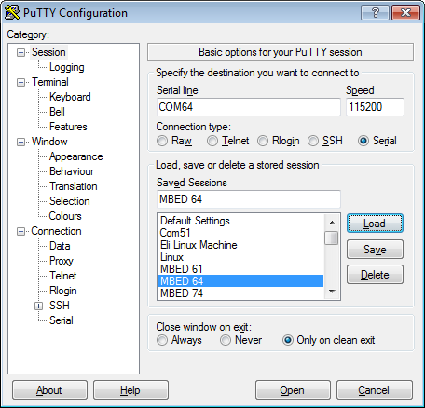

Speed: 115200

Serial Line: COM XX - should be your com number

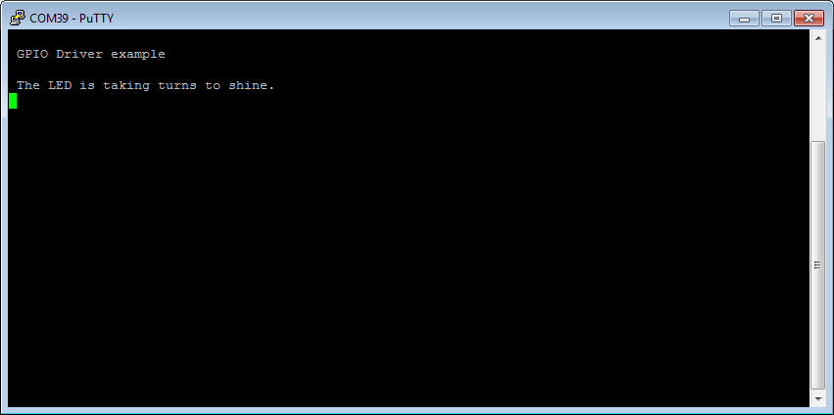

BTW , if you want to reset the board from the putty , you can do it by

Clicking Special command 🡪 break.

It is like pressing the reset button.

This was the first part of the tutorial.

We now know how to compile and load new firmware, view it on terminal.

Next we will go into the code and understand how the pin muxing is down , and where all the good staff happening.